# **Department of Computer Science and Engineering Islamic University of Technology (IUT)** A subsidiary organ of OIC

# **Lab Report 03**

# CSE 4412: Data Communication and Networking Lab

## 

## **Name : Khalid Hasan Ador Student ID: 210042102 Section: B Semester: Summer Academic Year: 2023-2024**

**Date of Submission: 11 February 2024**

### **Title:** Understanding the basics of Variable Length Subnet Mask (VLSM) and VLANs and Inter-VLAN communication

### **Objectives**:



### **Diagram of the experiment:**

(Provide screenshot of the final network topology. Make sure to label the network components.)

**TASK #01:**

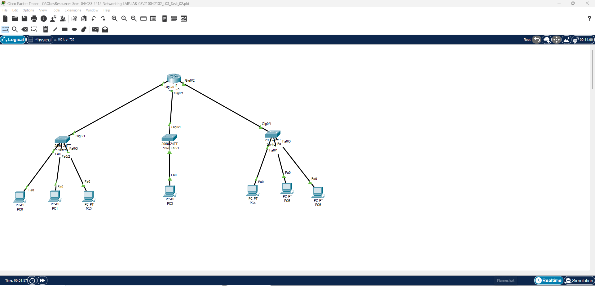

**TASK #02:**

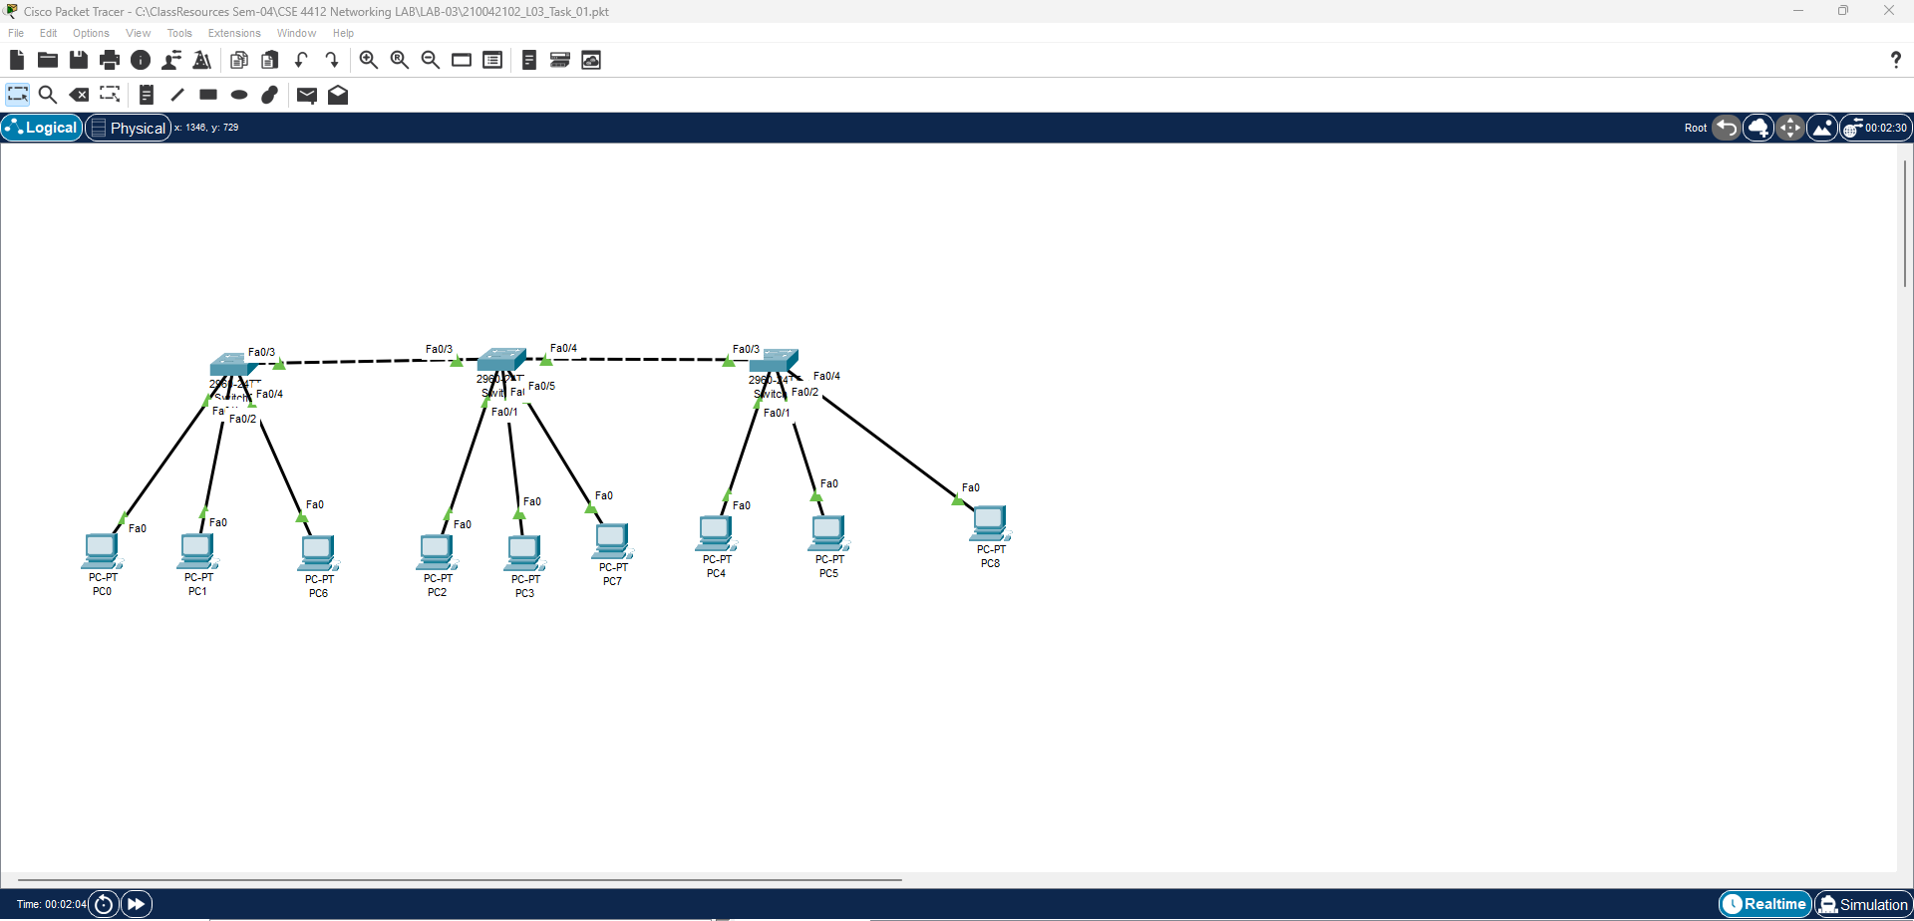

### **Working Procedure:**

**(**Explain in brief how you completed the tasks. Provide necessary screenshots of used commands for each task.)

**TASK #01:**

1. First of all made the existing network.
2. I was asked to add a subnetwork which will allow 21 hosts.
3. So we will need 5 bits to distinguish all the hosts.
4. So I made a /27 subnetwork.

**TASK #02:**

1. Made the required topology.
2. For switch 1:
3. Created the VLAN’s

switch(config)# vlan 10

switch(config)# vlan 20

switch(config)# vlan 30

1. Configured the interfaces

3 access link:

switch (config)# interface Fast-Ethernet 0/1

switch (config-if)# switchport mode access

switch (config-if)# switchport access vlan 10

switch (config-if)# no shutdown

1 trunk link:

switch (config)# interface Fast-Ethernet 0/4

switch (config-if)# switchport mode trunk

switch (config-if)# switchport trunk allowed vlan all

switch (config-if)# no shutdown

1. Repeated the same thing for all switches
2. SetUp the pc’s with appropriate IP and subnet masks.

### **Questions (Answer to the point)**:

* + - 1. How many host bits are needed in the largest required subnet?

**Ans:** 5.

As y=21

* + - 1. How many VLANs need to be configured to each of the switches?

**Ans:** 3

* + - 1. Which interfaces need Access Link?

**Ans:** Interfaces connected to the devices

* + - 1. Which interfaces need Trunk Link?

**Ans:** Interfaces connected to the other switches

* + - 1. After configuring VLAN, what will happen if we broadcast?

**Ans:** Only the devices in the same VLAN can communicate with each other.

### **Challenges (if any):**

### 